Paul R. Brown Leadership Academy

Technology Plan 2022 - 2023
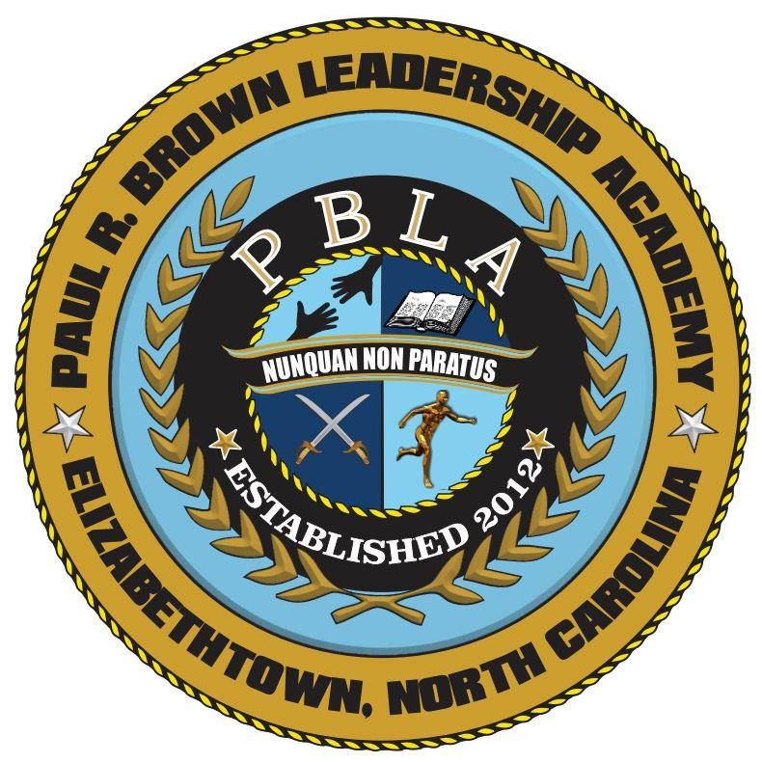

Superintendent: Dr. Jason M. Wray
Phone: (910) 862-2965
Email: jwray@prbla.org

1300 MLK Jr. Dr
Elizabethtown, NC 28337
PaulRBrownLeadership.com

TABLE OF CONTENTS

Description of Paul R. Brown Leadership Academy
A Unique Approach to Education Page 4
Vision and Mission Page 5

Teaching and Learning
Professional Development Page 6
Technology Integration Page 7
Student Achievement Page 8

Goals
Academic Technology Goals Page 9
Professional Learning Goals Page 14
Administrative/Organizational Technology Goals Page 16

Resources
Technology Staff Page 19
Teacher and Student Devices Page 20
Infrastructure Page 21

DESCRIPTION OF GRAND RAPIDS CHRISTIAN SCHOOLS

A Unique Approach to Education:

Paul R. Brown Leadership Academy improves cadet learning through a system that is currently provided for students at the 26 private military schools in the United States. This is a system which puts emphasis on becoming a whole person by taking responsibility for one’s own actions. The four pillars that the academy is built on are Academics, Character, Discipline, and Athletics. Cadets are rewarded with cadet rank and a position within the Corps of Cadets. For a cadet to be promoted he or she must be passing all classes with a certain GPA,(rank specific) complete so many hours of community service per promotion, receive a favorable evaluation from his/her cadet chain of command, a favorable evaluation from his/her teachers, and participate on one school athletic team per year. Paul R Brown always rewards cadet achievement every thirty days in academy parades and ceremonies. These ceremonies are open to parents and the public on Friday afternoons. The ideal is to always reward positive behavior every chance we are given. Under an academy system cadets learn quickly that negative behavior or failure to perform academically results in immediate consequences through the cadet discipline system. Cadets who fail a class are placed in Saturday study hall with a teacher. Cadets unprepared for class or failing to do assignments are placed in detention. Cadets who carry a failing grade for more than four weeks are placed in Saturday study halls.

Education Philosophy:

The educational philosophy, of Paul R. Brown Leadership Academy is grounded in the work of Tony Wagner’s The Global Achievement Gap, New York: Basic Books, 2008. Wagner’s seven survival skills for education today are the guiding principles by which Paul R. Brown Leadership Academy operates its school, builds its curriculum, and educates its students. While the seven principles are the basis (Critical Thinking and Problem Solving, Collaboration Across Networks and Leading by Influence, Agility and Adaptability, Initiative and Entrepreneurialism, Effective Oral and Written Communication, Accessing and Analyzing Information, and Curiosity and Imagination), the seven principles have been further refined and re-stated with the special Paul R. Brown Leadership Academy twist we call love of learning. This educational approach, model, theory, requires Paul R. Brown Leadership Academy teachers to be prepared daily and use a variety of teaching tools and techniques to keep cadets engaged, interested, and on the right track. Team work is stressed with cadets held to task by specific tasking, product based learning, classroom workshops, real experience, and critical review.
​

TECHNOLOGY VISION AND MISSION
Vision
The evolution and dynamics of technology has made a tremendous impact on our daily lives. Technology empowers productivity, promotes efficiencies, and creates opportunities for transforming learning. Technology has become a vehicle to help us in our journey of providing collaborative, data-informed instruction, adapting learning experiences to meet the needs of all learners. Our technology-rich learning environment allows us to transform our approaches to instruction and learning. Our vision for technology is to provide staff and students access to a variety of technologies that will enable them to cultivate an environment where staff and students learn, collaborate, create and innovate together.
Mission
Technology is a powerful, transformational tool that assists in helping us meet our mission statement. Technology is an integral part of our teaching and learning practices allowing us to transform, support and enhance our curriculum and communication. Technology assists us in providing an educational program which recognizes and values the uniqueness and learning needs of all students as they research, design, analyze, compose and communicate while teachers serve as facilitators of instruction, mentors, and coaches.
Executive Summary
This technology plan is intended to provide a comprehensive framework and planning document for the board, superintendent, building administration, building technology staff, teachers, support staff, parents, and students to guide the technology needs and support for the next three years at Paul R. Brown Leadership Academy. The technology plan addresses technology needs and planning in the categories of teaching and learning, professional development, and in an administrative/organization environment.

TEACHING AND LEARNING

PROFESSIONAL DEVELOPMENT

Professional development is an essential component of Paul R. Brown Leadership Academy’s plan to integrate technology into curriculum to support teaching and learning. Professional development for teachers, administrators, and other personnel will include awareness of technology standards and the continual development of technology literacies, strategies, and tools that support the integration of technology. Paul R. Brown Leadership Academy recognizes that just as technology is continually evolving, changing, and growing; so will the strategies for meeting its professional goals.
Technology professional development plans are focused around the following topics:
- Classroom management tools
- Collaboration tools
- Communication tools
- Content area resources and tools
- Formative and summative assessment tools
- Learning management systems
- Productivity and presentation tools
- Digital citizenship
Professional development opportunities are coordinated may be offered at different times and in different formats to maximize the opportunities for teacher participation. Paul R. Brown Leadership Academy will work to provide a balanced approach of formal professional development opportunities and informal support and training experiences. Trainings for all staff are provided at in-service days and in required staff meetings.

TECHNOLOGY INTEGRATION

Teaching practices are the key to effective instruction. Technology supports a teacher in delivering, scaling, and sustaining effective teaching practices providing tools that can allow a teacher to adapt and engage students with curriculum to meet the needs of all learners. Learning is enhanced by technology and it can transform teaching and learning, increase student engagement and motivation, authenticate learning, and increase critical thinking and collaboration skills.
Technology Integration Strategies:

  - Provide opportunities for teachers to learn new and existing technology and technology integration techniques.
  - Provide access to resources to assist teachers in integrating technology into their curriculum including resource links on the building level learning common’s web pages.
  - Introduce current and emerging technologies in the classroom.
  - Develop strategies to improve instruction and deepen learning resulting in increased student achievement that allows and encourages students to actively and collaboratively utilize the power of technology in their learning.
  - Collaborate with staff to develop and support active, hands-on learning opportunities for students so that there is a shift from students as consumers to students as creators.
  - Meet at least two times per year with classroom teachers to ensure technology integration in relationship to the standards.
  - Provides a web-based system for course delivery so that staff and students can access course resources anytime, anywhere.
  - Simplifies the learning process and procedures making it responsive to student’s needs.
  - Creates the opportunity for blended learning.
  - Enhances the opportunity for tracking and recording student progress to more efficiently provide data-driven instruction.

STUDENT ACHIEVEMENT

Empowering teachers to inspire minds and transforming instruction to deepen learning are part of our vision for equipping teachers with training, technology, and instructional environments that will enable them to put the best and most engaging teaching methods into practice with their students. It is vital that we encourage and empower students to be critical thinkers and problem solvers. We need to build an instructional framework that is data-based, research- driven, and employs a problem-solving approach across all areas of learning for all students, including those with special needs and those who are academically gifted. Our aim is to identify and offer the resources and tools, learning strategies, interdisciplinary connections, and flexible, collaborative learning environments necessary for all students to thrive.
Strategies to Improve Student Achievement Using Technology:
- Professional learning communities have been developed at Paul R. Brown Leadership Academy to support productive discussions among teachers about student learning, curriculum and instructional strategies.
- Teachers will use a variety of technology tools for formative and summative assessments to provide data-driven instruction and for using the immediate feedback that these tools offer.
- Teachers plan and incorporate technology tools and/or resources in the design, development and delivery of their lessons.
- All teachers will manage their courses in an online classroom providing students with 24/7 access to many course materials.
- The school will continue to support the one-to-one device program in grades six through twelve providing students with opportunities to collaborate, communicate, and create while using these tools.
- Instructional technology equipment will be supported throughout Paul R. Brown Leadership Academy to allow for interactions between the teacher, the student, and the curriculum.

GOALS

ACADEMIC TECHNOLOGY GOALS

Goal 1: Engage and empower a digital learning environment and culture of innovation that promotes data-informed instruction while meeting the needs of all learners.

Objective 1.1: Teachers design, develop, and evaluate learning experiences incorporating contemporary tools and resources to maximize content learning in context, and to develop the knowledge, skills, and attitudes identified in the technology standards.

Strategies | Measures/Evaluation Strategy | Responsibility
Use tools that increase student engagement in learning, productivity, creativity, critical thinking, and innovative activities | •Students show evidence of their learning through the development of a portfolio that captures snapshots of their digital activities  - Teachers and students select appropriate tech tools for the tasks assigned | Teaching Staff
Ensure equity and accessibility for all learners | - Utilize accessibility features such as speech-to-text and text-to-speech options for students  - Increased differentiated opportunities using technology for meeting the learning target  - In collaboration with media and student support services, increase the audio book collection in conjunction with the text version | Teaching Staff
Leverage online collaboration tools | - Needs assessment at the close of the year that shows teacher growth in collaborative activities | Teaching Staff
Establish authentic and/or global connections that engage students in the learning | - Ensure that global connections occur at least two times at the middle and high school level for each | Teaching Staff

process | student  - Increase authentic activities at each level

Objective 1.2: Teachers will use technology tools for assessments to collect data to make informed decisions about instruction while meeting the learning needs of individuals, groups, and classes.

Strategies | Measures/Evaluation Strategy | Responsibility
Expand the use of digital formative and summative assessment tools | •Document sample uses of video used as an assessment tool (such as screen casting, Flipgrid, Edpuzzle)  - Create a report on usage of Synergy assessment  - Staff survey on the tech tools used for assessment and frequency of usage | Teaching Staff
Assist teachers in interpreting and disaggregating their data to use it for instructional planning and to differentiate instruction using technology | - Staff survey on how efficiently the assessment tools used enabled them to better interpret and use the data  - Document sample remediation and instructional strategies that use technology to support differentiation  •Schedule time with individuals or teams to discuss next steps | Teaching Staff, and Building Administration

Objective 1.3: Teachers will create robust online classrooms that provide students with 24/7 access to a variety of resources, online activities and interactive, and the opportunity to extend their learning.

Strategies | Measures/Evaluation Strategy | Responsibility
Inform teachers of the expectation of the content of their online classroom | - Teachers show principal what is included in their online classroom during their evaluation process | Teaching Staff and Building Principal
Equip teachers with the skills needed to develop an online | - Increase in the number of teachers who have an active online classroom | Building Principal

classroom | presence

PROFESSIONAL LEARNING GOALS
Goal 3: Develop a culture of continuous, collaborative, and personalized learning to increase staff technology literacy aligned to the ISTE standards that support staff in their daily work and inspires and prepares them to integrate technology with curriculum standards.

Objective 3.1: Provide support to enable educators to continually leverage technology to improve student learning aligned to the technology standards.

Strategies | Measures/Evaluation Strategy | Responsibility
Increase the visibility of the ISTE standards | •Post the standards in the lounge and in tech/learning commons areas | Building Principal
Meet individually with all teaching staff to help them grow in their use of technology | •Building staff will meet with each teacher at least 2 times per year to plan and implement at least one area for growing in technology skills, confidence, and/or integration each year  •Follow-up reflection will provide measurable data on student learning and the impact this goal had on the teacher’s future teaching practice | Building Principal
Share new, innovative, and emerging technologies with staff | •Visible evidence of technology tools being used in classrooms for integration, assessment, and communication | Building Principal

Objective 3.2: Plan and lead professional development activities that provide teachers with a variety of pathways to lead and learn in technology integration.

Strategies | Measures/Evaluation Strategy | Responsibility
Conduct a technology needs assessment | - Data collected will be reviewed by tech and curriculum staff to determine learning needs for staff | Building Principal and Curriculum Staff
Encourage staff members to participate in webinars and other online opportunities | - Gather and disseminate availability of learning opportunities | Building Principal and Curriculum Staff
Continue to provide sessions for all staff on new and emerging technologies as well as updates and refreshers in a variety of environments | - Document attendance lists  - Collect comments and notes through exit tickets | Building Principal and Curriculum Staff

ADMINISTRATIVE/ORGANIZATIONAL TECHNOLOGY GOALS
Goal 4: Provide effective and efficient communication systems.

Objective 4.1: Implement an alert notification system that can provide responsive communication between school and home starting the 2022-2023 school year.

Strategies | Measures/Evaluation Strategy | Responsibility
Research notification systems | - Identify a team of principals, tech staff, and administrative assistants to review one or more demos from the final selection of systems | Building Principal
Implement a notification system | - Implement a system summer of 2022 that integrates with Synergy | Building Principal
Objective 4.2: Equip the administrative staff on utilization of the notification.

Strategies | Measures/Evaluation Strategy | Responsibility
Train administrative staff on how to use the system | - At least 2 people from each school will be trained on how to use the selected notification system | Building Principal
Develop a best practice usage guide | - Create and distribute best practices to the notification system users | Building Principal

Goal 5: Foster and sustain systems that provide safe and secure learning environments.

Objective 5.1: The technology team will communicate knowledge of our internet filter parent portal with parents, as well as best practices for using school technology devices in the home.

Strategies | Measures/Evaluation Strategy | Responsibility
Continue to provide resources and support for parents to ensure Internet safety | •Include tips in home bulletins  - Create and post on our website an internet filter user guide  - Include information on parent portals in summer mailings | Building Principal
Objective 5.2: The technology team will review and evaluate products to keep our online environment safe, while providing access to resources and products beneficial for education.

Strategies | Measures/Evaluation Strategy | Responsibility
Annually review our internet filter systems, Responsible Use Policy, and infrastructure | - Discuss and collect feedback from building administration  - View data and reports collected from monitoring tools | Building Principal

Objective 5.3: Develop a disaster recovery plan establishing connectivity and service to schools in the event of a crisis, emergency or disaster.

Strategies | Measures/Evaluation Strategy | Responsibility
Develop a plan to minimize interruptions to normal operations, to establish alternative means of operation, and to provide for a smooth and rapid restoration of service | - Document external vendors with their contact information and support for re- establishing service  - Document application profiles with their name, critical level, manufacturer, and run data  - Document inventory with manufacturer, description, model, and serial number  - Document backup strategy  - Document emergency response | Building Principal

procedures, backup operation procedures, and recovery action procedures
- Document risk management with a brief description of potential consequences and remedial actions for flood, fire, tornado, electrical failure, sabotage,

STUDENT AND TEACHER DEVICES

Paul R. Brown Leadership Academy is equipped with multiple technology tools for teacher and student use. Classroom teachers have a laptop assigned to them and the availability of a teacher iPad. They also have OneScreen Monitors in their rooms as well as web cameras.
Our Exceptional Children’s have shared iPad carts and shared laptop carts. Desktops are scattered throughout the building for paraprofessionals to use.
Paul R. Brown Leadership Academy is a one to one with technology devices school. From grades six through twelve, students are allowed to take home their devices.
Our current device life cycle is approximately four to seven years. Our one to one student devices are on a four-year life cycle. Staff devices typically are refreshed on a five-year cycle. Desktops are refreshed every six to eight years.

